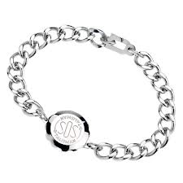

This bracelet is an ultimate expression of romance. With the enhanced technical mastery, it represents everlasting appleal and can match all special occasion

Product: BRACELET

Price:1,250.00 PKR

CONTACT US: Address: Aptech Metro StarGate Karachi

Phone.no: 03142191402

Email: feedback@aptech-educationcom.pk